

**Prime-Fitness**

**E-Project Documentation**

**Teacher Name: Miss Arzoo Ansari**

**APTECH COMPUTER EDUCATION**

**HYDERABAD-1 PAKISTAN**

**Issue Date: 23-June-2025**

TABLE OF CONTENT

|  |  |  |
| --- | --- | --- |
| **S No** | **Contents** | **Page No** |
| 01 | Certificate | 3 |
| 02 | Acknowledgement | 4 |
| 03 | Project Report | 5 |
| 04 | Problem Definition | 6 |
| 05 | Customer Requirements Specification  (CRS) | 7 |
| 06 | Architecture Design of the Project | 8 |
| 07 | System Requirement | 9 |
| 08 | Task Sheet | 10 |
| 09 | Project Plan | 11 |
| 10 | Checklist of work Progress | 12 |
| 11 | Final Check List | 13 |
| 12 | Screen Shots | 18 |
| 13 | Source Code | 20 |

CERTIFICATE

This is to certify that

**Abbi Gail, Muhammad Ashhad, Muhammad Bilal, Syed Asharib Ali, Muhammad Ahmed**

Submitted by:

**Abbi Gail, Muhammad Ashhad, Muhammad Bilal, Syed Asharib Ali, Muhammad Ahmed**

Has successfully designed

Prime-Fitness

Date of Issue: **23-June-2025**

Authorized Signature: Ms. Arzoo Ansari

ACKNOWLEDGEMENT

First and foremost, we would like to express our deep gratitude and most heartfelt thanks to almighty ALLAH for his blessings, for lightening up our heart with the torch of knowledge and for giving us the ability to complete this project.

We would like to thanks Aptech Worldwide and the team of E-Project for their generous support and clarifying the doubts regarding e-project. We would like to acknowledge the way of explanation which the team of e-project gave in e-project to make website and we are equally grateful to our teacher (Ms. Arzoo Ansari) for giving us a moral support and guiding us different matters regarding project in all the time about the research and writing of this project.

We are greatly indebted to Aptech Worldwide, Miss Arzoo, Faculty Members and ACE Hyderabad, Pakistan for encouragement and incessant help.

PROJECT REPORT

**BY:**

|  |  |  |  |  |
| --- | --- | --- | --- | --- |
| Student1635357 | | |  | | --- | | ABBI GAIL | | |
| Student1635448 | | MUHAMMAD ASHHAD | |
| Student1635378 | | MUHAMMAD BILAL | |
| Student1635537 | | SYED ASHARIB ALI | |
| Student1635440 | | MUHAMMAD AHMED | |
|  | |  | |
|  | |  | |
|  | |  | |

Project Title: Prime Fitness

Members Name: Abbi Gail, Muhammad Ashhad, Muhammad Bilal, Muhammad Ahmed, Syed Asharib Ali

Batch Code: 2412B-1

Start Date: 23-June -2025

End Date: 15-July -2025

Course: ACCP-PRIME (ADSE)

Teacher: Miss Arzoo Ansari

Center Manager: Sir Shoaib Ahmed

Center Academic Head: Sir Shoaib Ahmed

Center Name: ACE Hyderabad-1, Pakistan

Submitted as

E Project Documentation

**PROBLEM STATEMENT**

Prime Fitness is fitness club established in the year 1982. The fitness club has equipped with all basic fitness equipment and also included the newly introduced. The Prime fitness club is the flagship brand for Prime Fitness Club Ltd, a UN based health and fitness services provider and a pioneer in the “Integrated Health Club Management Solutions’ business. Prime Fitness Club ltd focuses on staying fit is most important to meet the challenging requirements.

**Requirement Specification:**

The Web site is to be created based on the following requirements.

1. Home page should be designed with the appropriate template and navigational link.
2. Designing and navigation both must be made user friendly.
3. Links can be:
   * Cycling
   * Swimming
   * Sports & Fitness
   * Group Exercise
   * Membership
   * Salon & Spa
   * Gallery
   * List of equipments with its description.
4. About us
5. FAQ’s
6. Enquiry Form
7. Site Map

Architecture & Design of the Project:

Since the website will have client architecture it will have one-tier architecture.

System Requirement:

|  |  |  |
| --- | --- | --- |
| **SR.No** | **Items** | **Description** |
| 01 | Operating System | Window XP, Win7 or win8 |
| 02 | Main Processor | Minimum 2ghz or better |
| 03 | Ram (Memory) | 64Megabytes or better |
| 04 | Web Browser | Google Chrome or Firefox (Latest) |
| 05 | Software | Notepad/HTMLeditor/CoffeeCup  Angular / Angular JS / React /BootStrap Dreamweaver /Figma MS IE / Chrome / FireFox / Netscape /MS Edge |

TASK SHEET

|  |  |  |  |  |  |
| --- | --- | --- | --- | --- | --- |
| **Project Ref. No:** | | **Date of Preparation of Activity Plan:** | | | |
| SR.  No | Task | Actual  Start  Date: | Actual  Day: | Team  Mates  Names: | Status: |
| 01 | Meeting | 23 Jun 2025 | 1 | Abbi Gail |  |
| 02 | Data  Collection | 25 Jan 2025 | 2 | Muhammad Ashhad |  |
| 03 | Designing  Home  Page | 1 July 2025 | 4 | Muhammad Ashhad |  |
| 04 | Linking | 5 July 2025 | 1 | Muhammad Bilal |  |
| 05 | Check  Links | 7 July 2025 | 1 | Muhammad Ahmed |  |
| 06 | Designing Menu Page | 14 July 2025 | 2 | Syed Asharib Ali |  |
| 07 | Designing Other Pages | 27 Jan 2024 | 5 | Abbi Gail, Muhammad Ashhad, Muhammad Bilal |  |
| 06 | Finalizing | 1 Feb 2024 | 1 | Muhammad Ashhad |  |
| 08 | Documentation | 2 Feb 2024 | 1 | Abbi Gail |  |
| 09 | Uploading | 5 Feb 2024 | 1 | Muhammad Ashhad |  |

PROJECT PLAN

* Website is able to execute quickly.
* The color combination of our website is so attractive.
* The collection of data is authentic and taken by the most popular product websites.
* Background of each page is as different as the main page.
* The contact page is well prepared exactly for the same page as user clicks on the link...
* A user can resolve its difficulties easily from this site.

CHECK LIST OF WORK PROGRESS

|  |  |  |
| --- | --- | --- |
| **SR. No** | **Aspect Tested** | **Remarks** |
| 01 | Data Collection |  |
| 02 | Designing Home Page |  |
| 03 | Linking The Pages |  |
| 04 | Designing Other Pages |  |
| 05 | Finalization |  |
| 06 | Documentation |  |

FINAL CHECK LIST

|  |  |  |  |
| --- | --- | --- | --- |
| **SR.No** | **Particulars** | **Yes** | **No** |
| 01 | Do all pages open? | YES |  |
| 02 | Are all hyperlinks working? | YES |  |
| 03 | Are the web page contents devoid for spelling mistakes? | YES |  |
| 04 | Are all the web components working? | YES |  |
| 05 | Is site browser compatible? | YES |  |

SCREEN SHOTS:

HOME PAGE

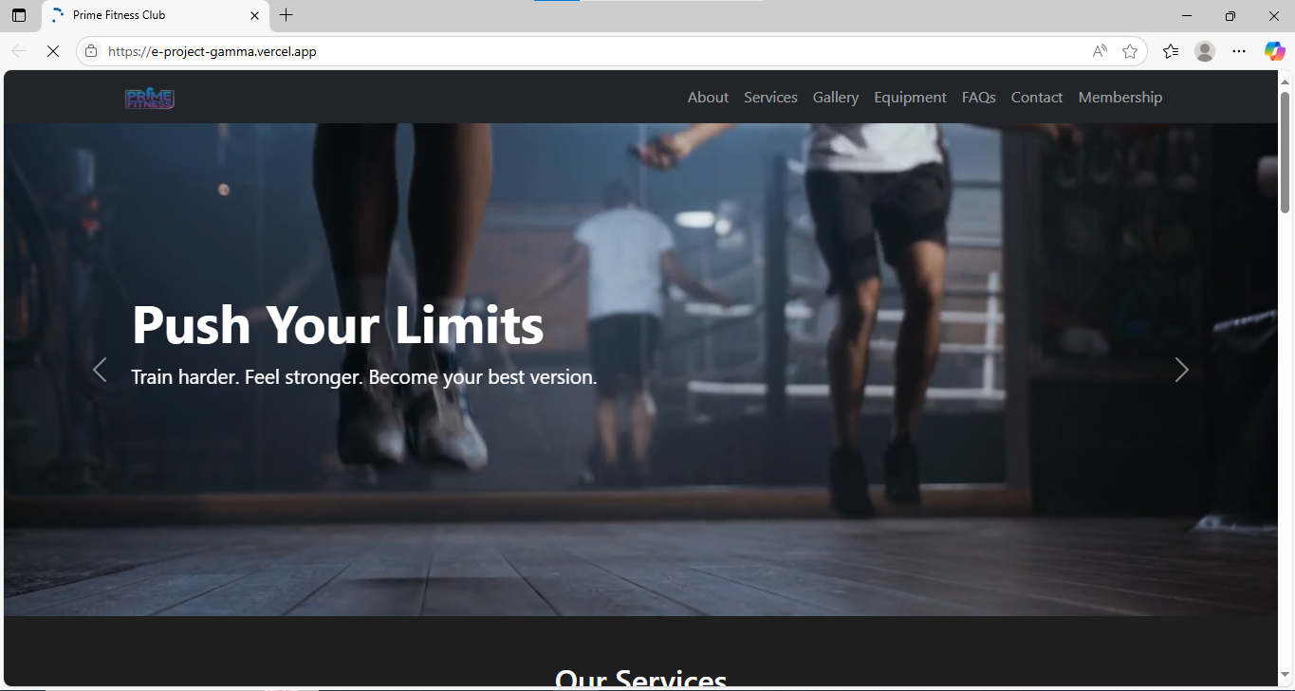

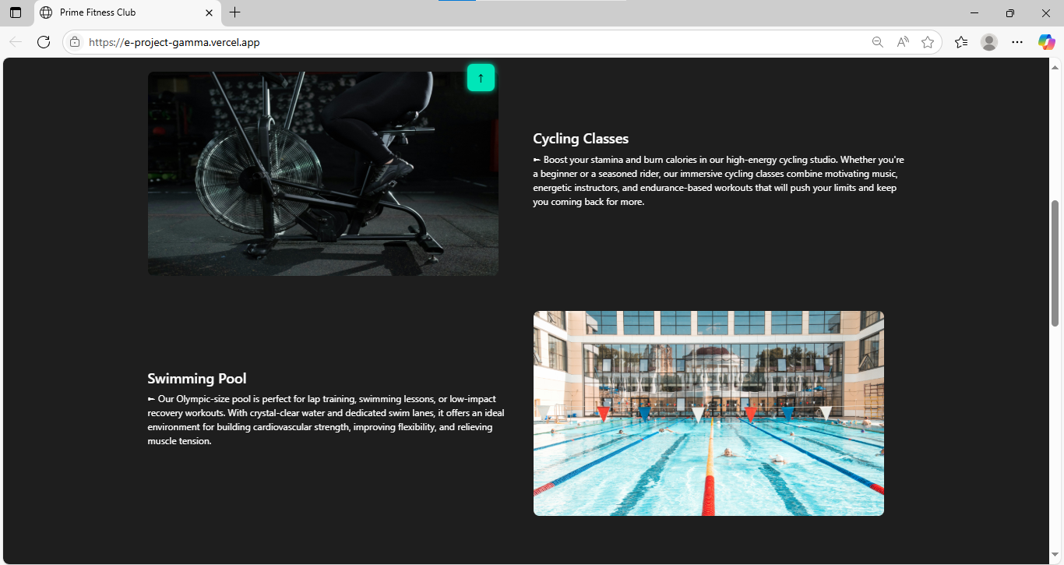

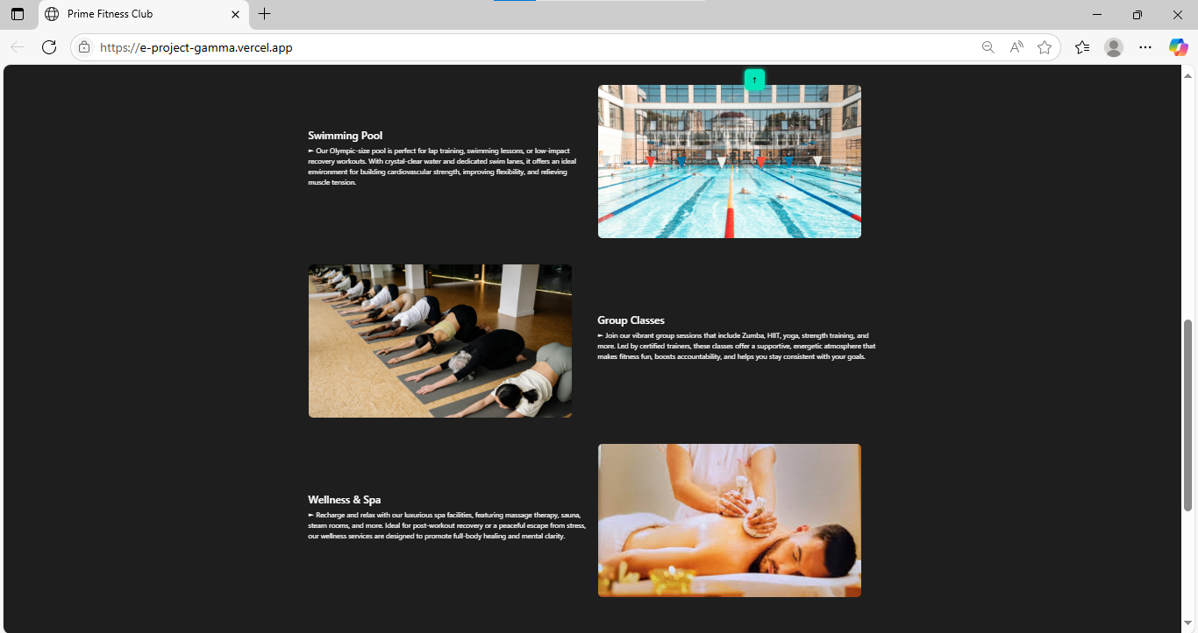

About PAGE

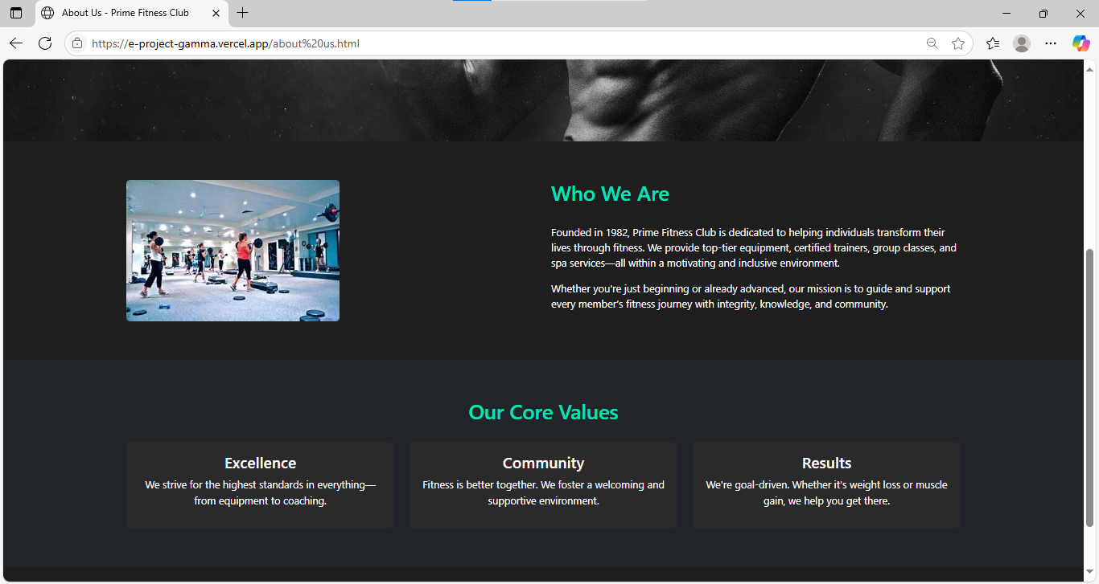Gallery PAGE

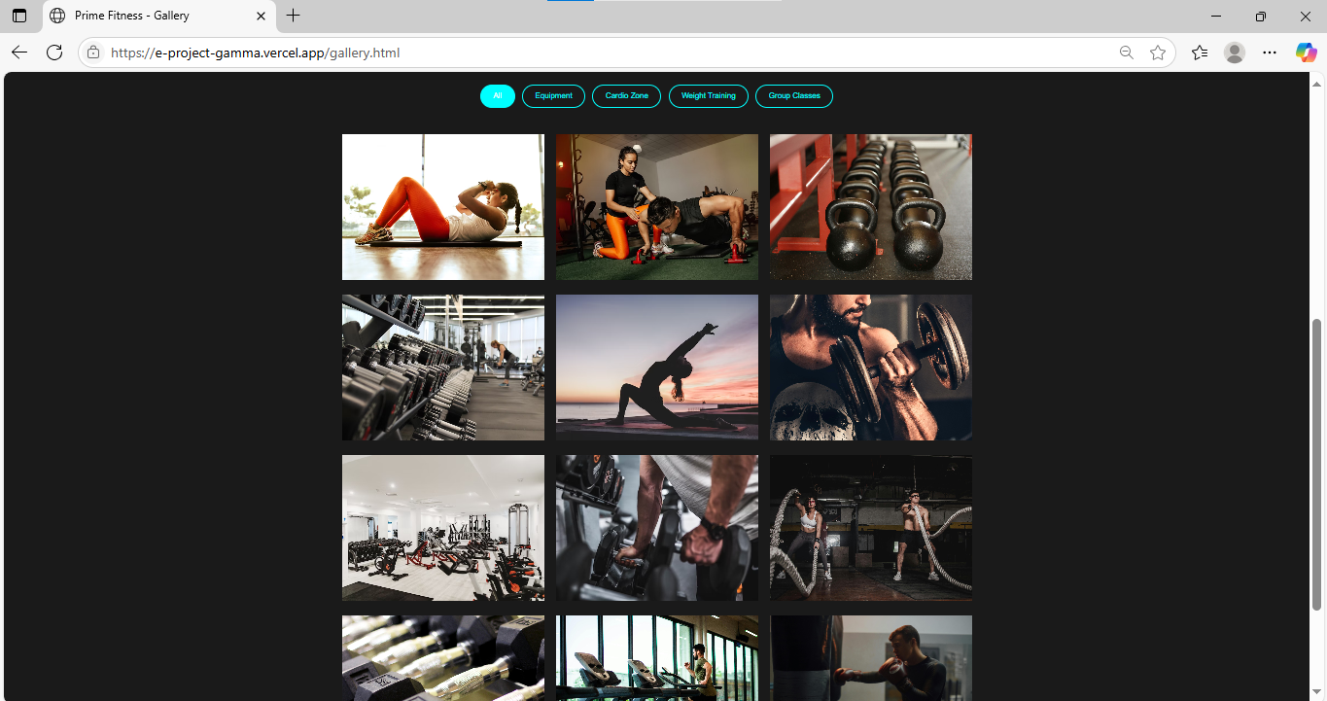

Equipment Page

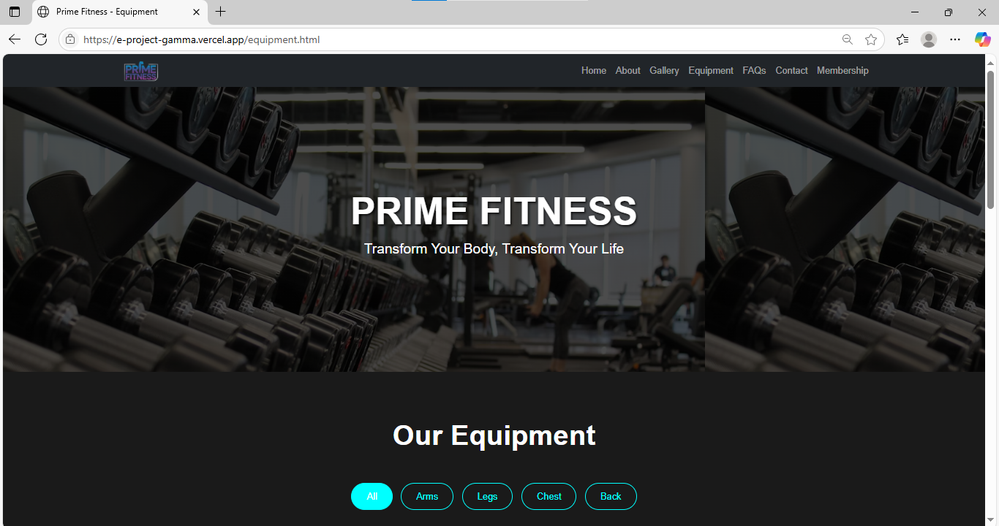

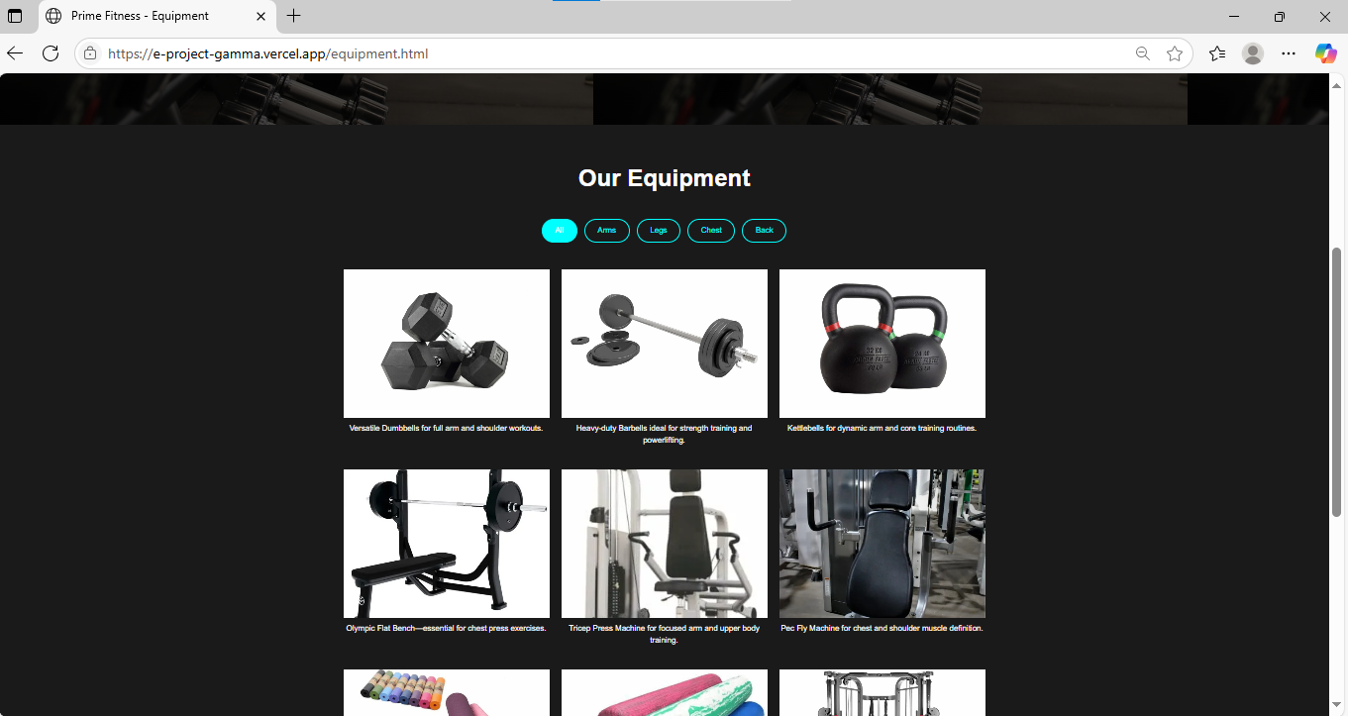

FaQ Page

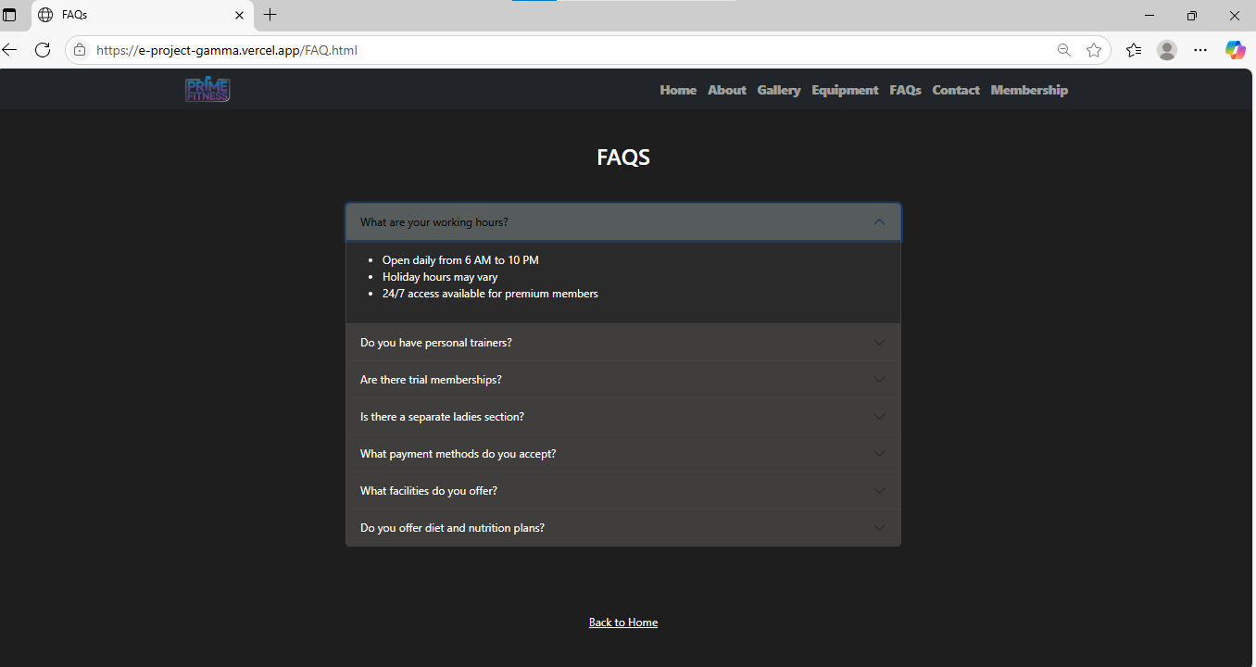

**Member Ship Page**

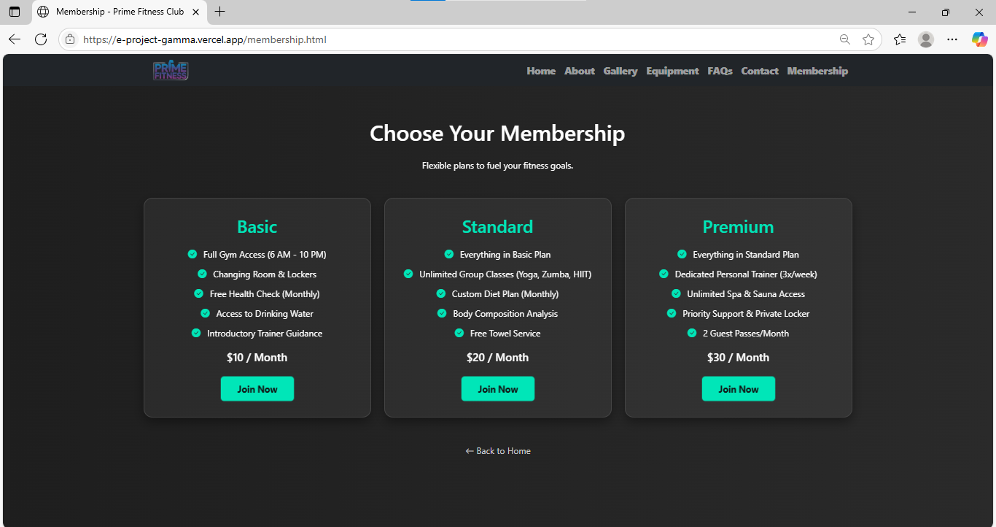

**Contact Page**

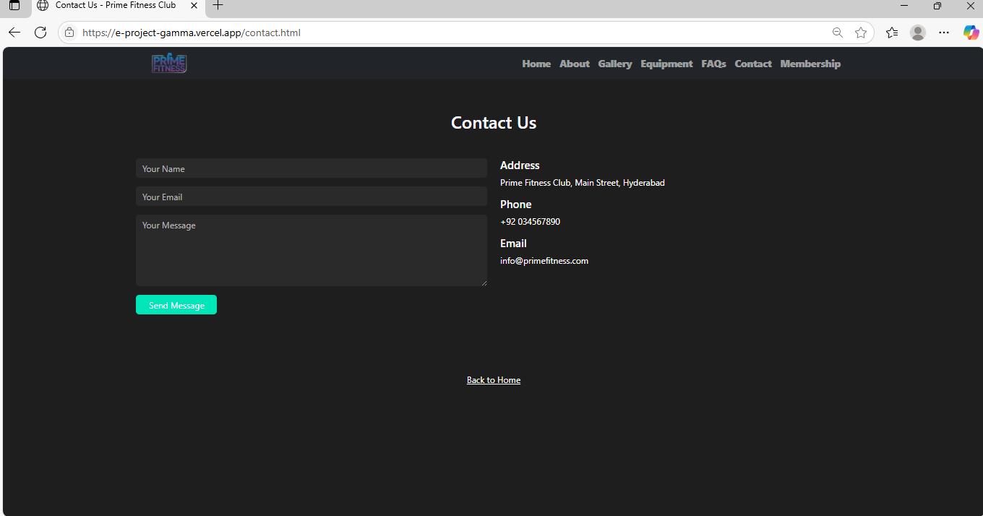

**Source Code**

</html>

<!DOCTYPE html>

<html lang="en">

<head>

<meta charset="UTF-8" />

<meta name="viewport" content="width=device-width, initial-scale=1.0" />

<title>Prime Fitness Club</title>

<link href="https://cdn.jsdelivr.net/npm/bootstrap@5.3.3/dist/css/bootstrap.min.css" rel="stylesheet"/>

<link href="https://cdnjs.cloudflare.com/ajax/libs/animate.css/4.1.1/animate.min.css" rel="stylesheet"/>

<link href="https://cdn.jsdelivr.net/npm/bootstrap-icons@1.10.5/font/bootstrap-icons.css" rel="stylesheet"/>

<link href="https://cdn.jsdelivr.net/npm/aos@2.3.4/dist/aos.css" rel="stylesheet">

</head>

<body>

<div id="preloader">

<div class="spinner"></div>

</div>

<button onclick="scrollToTop()" id="backToTopBtn" title="Go to top">↑</button>

<!-- Navbar -->

<nav class="navbar navbar-expand-lg navbar-dark bg-dark">

<div class="container">

<a class="navbar-brand" href="index.html">

<img src="images/173a2562-1c56-4cb6-b316-3125440d36a6-removebg-preview.png" alt="Logo" style="height:60px"/>

</a>

<button class="navbar-toggler" type="button" data-bs-toggle="collapse" data-bs-target="#navbarNav">

<span class="navbar-toggler-icon"></span>

</button>

<div class="collapse navbar-collapse" id="navbarNav">

<ul class="navbar-nav ms-auto">

<li class="nav-item"><a class="nav-link" href="about us.html">About</a></li>

<li class="nav-item"><a class="nav-link" href="#services">Services</a></li>

<li class="nav-item"><a class="nav-link" href="gallery.html">Gallery</a></li>

<li class="nav-item"><a class="nav-link" href="equipment.html">Equipment</a></li>

<li class="nav-item"><a class="nav-link" href="FAQ.html">FAQs</a></li>

<li class="nav-item"><a class="nav-link" href="contact.html">Contact</a></li>

<li class="nav-item"><a class="nav-link" href="membership.html">Membership</a></li>

</ul>

</div>

</div>

</nav>

<!-- Carousel -->

<section class="video-carousel">

<div id="heroCarousel" class="carousel slide" data-bs-ride="carousel" data-bs-interval="5000">

<div class="carousel-inner">

<div class="carousel-item active">

<video class="d-block w-100" autoplay loop muted>

<source src="videos/4761426-uhd_4096_2160_25fps (online-video-cutter.com).mp4" type="video/mp4">

</video>

</div>

<div class="carousel-item">

<video class="d-block w-100" autoplay loop muted>

<source src="videos/6389564-uhd_3840_2160_25fps (online-video-cutter.com).mp4" type="video/mp4">

</video>

</div>

<div class="carousel-item">

<video class="d-block w-100" autoplay loop muted>

<source src="videos/4761711-uhd_4096_2160_25fps (online-video-cutter.com).mp4"4 type="video/mp4">

</video>

</div>

</div>

<button class="carousel-control-prev" type="button" data-bs-target="#heroCarousel" data-bs-slide="prev">

<span class="carousel-control-prev-icon"></span>

</button>

<button class="carousel-control-next" type="button" data-bs-target="#heroCarousel" data-bs-slide="next">

<span class="carousel-control-next-icon"></span>

</button>

<div class="carousel-caption d-none d-md-block">

<h1>Push Your Limits</h1>

<p>Train harder. Feel stronger. Become your best version.</p>

</div>

</div>

</section>

<!-- Services Section -->

<section id="services" class="container py-5">

<div class="text-center mb-5"><h2>Our Services</h2></div>

<div class="row align-items-center service-card" data-aos="fade-right" data-aos-delay="0">

<div class="col-md-6">

<img src="images/pexels-cottonbro-7689295.jpg" class="img-fluid" alt="Cycling">

</div>

<div class="col-md-6">

<h4>Cycling Classes</h4>

<p>

► Boost your stamina and burn calories in our high‑energy cycling studio. Whether you're a beginner or a seasoned rider, our immersive cycling classes combine motivating music, energetic instructors, and endurance-based workouts that will push your limits and keep you coming back for more.

</p>

</div>

</div>

<div class="row align-items-center service-card flex-row-reverse" data-aos="fade-left" data-aos-delay="200">

<div class="col-md-6">

<img src="images/pexels-69035116-8328775.jpg" class="img-fluid" alt="Swimming ">

</div>

<div class="col-md-6">

<h4>Swimming Pool</h4>

<p>

► Our Olympic‑size pool is perfect for lap training, swimming lessons, or low-impact recovery workouts. With crystal-clear water and dedicated swim lanes, it offers an ideal environment for building cardiovascular strength, improving flexibility, and relieving muscle tension.

</p>

</div>

</div>

<div class="row align-items-center service-card" data-aos="fade-right" data-aos-delay="400">

<div class="col-md-6">

<img src="images/pexels-yankrukov-8436583.jpg" class="img-fluid" alt="Group Classes">

</div>

<div class="col-md-6">

<h4>Group Classes</h4>

<p>

► Join our vibrant group sessions that include Zumba, HIIT, yoga, strength training, and more. Led by certified trainers, these classes offer a supportive, energetic atmosphere that makes fitness fun, boosts accountability, and helps you stay consistent with your goals.

</p>

</div>

</div>

<div class="row align-items-center service-card flex-row-reverse" data-aos="fade-left" data-aos-delay="800">

<div class="col-md-6">

<img src="images/images.jpg" class="img-fluid" alt="Spa">

</div>

<div class="col-md-6">

<h4>Wellness & Spa</h4>

<p>

► Recharge and relax with our luxurious spa facilities, featuring massage therapy, sauna, steam rooms, and more. Ideal for post-workout recovery or a peaceful escape from stress, our wellness services are designed to promote full-body healing and mental clarity.

</p>

</div>

</div>

</section>

<!-- Reviews Section -->

<section class="py-5 bg-dark">

<div class="container">

<h2 class="text-center mb-5">What Our Members Say</h2>

<div class="row text-center">

<div class="col-md-4"><div class="review-card"><i class="bi bi-person-circle fs-2"></i>

<p>"Prime Fitness gave me the motivation I needed!"</p><strong> - Member A</strong>

<p class="text-warning">★★★★★</p>

</div></div>

<div class="col-md-4"><div class="review-card"><i class="bi bi-person-circle fs-2"></i>

<p>"Excellent equipment and super friendly staff. Very Satisfied"</p><strong>- Member B</strong>

<p class="text-warning">★★★★★</p>

</div></div>

<div class="col-md-4"><div class="review-card"><i class="bi bi-person-circle fs-2"></i>

<p>"Loving the group classes—they keep me consistent."</p><strong>- Member C</strong>

<p class="text-warning">★★★★★</p>

</div></div>

</div>

</div>

</section>

<!-- Footer -->

<footer class="text-center">

<div class="container">

<div class="row">

<div class="col-md-4 mb-3">

<h5>Prime Fitness Club</h5>

<p>&copy; 2025 All Rights Reserved</p>

</div>

<div class="col-md-4 mb-3">

<h5>Quick Links</h5>

<ul class="list-unstyled">

<li><a href="about us.html">About</a></li>

<li><a href="#services">Services</a></li>

<li><a href="gallery.html">Gallery</a></li>

<li><a href="contact.html">Contact</a></li>

</ul>

</div>

<div class="col-md-4 mb-3">

<h5>Contact</h5>

<p>Email: info@primefitness.com</p>

<p>Phone: +92 300 1234567</p>

<div>

<a href="#" class="me-2"><i class="bi bi-facebook"></i></a>

<a href="#" class="me-2"><i class="bi bi-instagram"></i></a>

<a href="#"><i class="bi bi-twitter"></i></a>

</div>

</div>

</div>

</div>

</footer>

<script

}

</script>

</body>

</html>

<!DOCTYPE html>

<html lang="en">

<head>

<meta charset="UTF-8" />

<meta name="viewport" content="width=device-width, initial-scale=1.0"/>

<title>About Us - Prime Fitness Club</title>

<link href="https://cdn.jsdelivr.net/npm/bootstrap@5.3.3/dist/css/bootstrap.min.css" rel="stylesheet" />

<style>

</style>

</head>

<body>

<nav class="navbar navbar-expand-lg navbar-dark bg-dark">

<div class="container" style="font-weight: 900; font-size: large;">

<a class="navbar-brand d-flex align-items-center" href="index.html">

<img src="images/173a2562-1c56-4cb6-b316-3125440d36a6-removebg-preview.png" alt="Logo" class="logo-img" style="position: absolute;">

</a>

<button class="navbar-toggler" type="button" data-bs-toggle="collapse" data-bs-target="#navbarNav">

<span class="navbar-toggler-icon"></span>

</button>

<div class="collapse navbar-collapse" id="navbarNav">

<ul class="navbar-nav ms-auto">

<li class="nav-item"><a class="nav-link" href="index.html">Home</a></li>

<li class="nav-item"><a class="nav-link" href="about us.html">About</a></li>

<li class="nav-item"><a class="nav-link" href="gallery.html">Gallery</a></li>

<li class="nav-item"><a class="nav-link" href="equipment.html">Equipment</a></li>

<li class="nav-item"><a class="nav-link" href="FAQ.html">FAQs</a></li>

<li class="nav-item"><a class="nav-link" href="contact.html">Contact</a></li>

<li class="nav-item"><a class="nav-link" href="membership.html">Membership</a></li>

</ul>

</div>

</div>

</nav>

<!-- Hero Banner -->

<section class="about-hero text-center">

</section>

<!-- About Content -->

<section class="section">

<div class="container">

<div class="row align-items-center">

<div class="col-md-6">

<img src="images/WhatsApp Image 2025-07-03 at 1.36.47 PM.jpeg" class="img-fluid rounded" alt="Gym Overview" />

</div>

<div class="col-md-6">

<h2>Who We Are</h2>

<p>Founded in 1982, Prime Fitness Club is dedicated to helping individuals transform their lives through fitness. We provide top-tier equipment, certified trainers, group classes, and spa services—all within a motivating and inclusive environment.</p>

<p>Whether you're just beginning or already advanced, our mission is to guide and support every member’s fitness journey with integrity, knowledge, and community.</p>

</div>

</div>

</div>

</section>

<!-- Values -->

<section class="section bg-dark">

<div class="container">

<h2 class="text-center">Our Core Values</h2>

<div class="row g-4">

<div class="col-md-4">

<div class="card p-3 text-center">

<h4>Excellence</h4>

<p>We strive for the highest standards in everything—from equipment to coaching.</p>

</div>

</div>

<div class="col-md-4">

<div class="card p-3 text-center">

<h4>Community</h4>

<p>Fitness is better together. We foster a welcoming and supportive environment.</p>

</div>

</div>

<div class="col-md-4">

<div class="card p-3 text-center">

<h4>Results</h4>

<p>We're goal-driven. Whether it's weight loss or muscle gain, we help you get there.</p>

</div>

</div>

</div>

</div>

</section>

<div class="text-center mt-5">

<a href="index.html" class="back-link">

<i class="bi bi-arrow-left"></i> Back to Home

</a>

</div>

<!-- Footer -->

<footer class="bg-black text-center text-white py-3">

<p class="mb-0">© 2025 Prime Fitness Club. All rights reserved.</p>

</footer>

</body>

</html>

<!DOCTYPE html>

<html lang="en">

<head>

<meta charset="UTF-8">

<meta name="viewport" content="width=device-width, initial-scale=1.0">

<title>Prime Fitness - Gallery</title>

<!-- Bootstrap CSS -->

<link href="https://cdnjs.cloudflare.com/ajax/libs/bootstrap/5.3.0/css/bootstrap.min.css" rel="stylesheet">

<!-- Bootstrap Icons -->

<link href="https://cdnjs.cloudflare.com/ajax/libs/bootstrap-icons/1.10.0/font/bootstrap-icons.min.css" rel="stylesheet">

<style>

</style>

</head>

<body>

<nav class="navbar navbar-expand-lg navbar-dark bg-dark">

<div class="container">

<a class="navbar-brand d-flex align-items-center" href="index.html">

<img src="images/173a2562-1c56-4cb6-b316-3125440d36a6-removebg-preview.png" alt="Logo" class="logo-img">

</a>

<button class="navbar-toggler" type="button" data-bs-toggle="collapse" data-bs-target="#navbarNav">

<span class="navbar-toggler-icon"></span>

</button>

<div class="collapse navbar-collapse" id="navbarNav">

<ul class="navbar-nav ms-auto">

<li class="nav-item"><a class="nav-link" href="index.html">Home</a></li>

<li class="nav-item"><a class="nav-link" href="about us.html">About</a></li>

<li class="nav-item"><a class="nav-link" href="gallery.html">Gallery</a></li>

<li class="nav-item"><a class="nav-link" href="equipment.html">Equipment</a></li>

<li class="nav-item"><a class="nav-link" href="FAQ.html">FAQs</a></li>

<li class="nav-item"><a class="nav-link" href="contact.html">Contact</a></li>

<li class="nav-item"><a class="nav-link" href="membership.html">Membership</a></li>

</ul>

</div>

</div>

</nav>

<section class="hero-section">

<div>

<h1 class="hero-title">PRIME FITNESS</h1>

<p class="hero-subtitle">Transform Your Body, Transform Your Life</p>

</div>

</section>

<section class="gallery-section">

<div class="container">

<h2 class="section-title">Our Facility</h2>

<div class="filter-buttons">

<button class="filter-btn active" data-filter="all">All</button>

<button class="filter-btn" data-filter="equipment">Equipment</button>

<button class="filter-btn" data-filter="cardio">Cardio Zone</button>

<button class="filter-btn" data-filter="weights">Weight Training</button>

<button class="filter-btn" data-filter="classes">Group Classes</button>

</div>

<div class="row gallery-grid">

<div class="col-lg-4 col-md-6 gallery-item" data-category="equipment">

<img src="https://images.unsplash.com/photo-1571019613454-1cb2f99b2d8b?ixlib=rb-4.0.3&auto=format&fit=crop&w=800&q=80" alt="Modern Gym Equipment">

</div>

<div class="col-lg-4 col-md-6 gallery-item" data-category="cardio">

<img src="https://images.unsplash.com/photo-1571019614242-c5c5dee9f50b?ixlib=rb-4.0.3&auto=format&fit=crop&w=800&q=80" alt="Cardio Zone">

</div>

<div class="col-lg-4 col-md-6 gallery-item" data-category="weights">

<img src="images/pexels-pixabay-416717.jpg" alt="Cardio Zone">

</div>

<div class="col-lg-4 col-md-6 gallery-item" data-category="weights">

<img src="https://images.unsplash.com/photo-1534438327276-14e5300c3a48?ixlib=rb-4.0.3&auto=format&fit=crop&w=800&q=80" alt="Weight Training">

</div>

<div class="col-lg-4 col-md-6 gallery-item" data-category="classes">

<img src="https://images.unsplash.com/photo-1544367567-0f2fcb009e0b?ixlib=rb-4.0.3&auto=format&fit=crop&w=800&q=80" alt="Group Classes">

</div>

<div class="col-lg-4 col-md-6 gallery-item" data-category="classes">

<img src="images/pexels-cesar-galeao-1673528-3289711.jpg" alt="Group Classes">

</div>

<div class="col-lg-4 col-md-6 gallery-item" data-category="equipment">

<img src="https://images.unsplash.com/photo-1540497077202-7c8a3999166f?ixlib=rb-4.0.3&auto=format&fit=crop&w=800&q=80" alt="Equipment">

</div>

<div class="col-lg-4 col-md-6 gallery-item" data-category="weights">

<img src="https://images.unsplash.com/photo-1583454110551-21f2fa2afe61?ixlib=rb-4.0.3&auto=format&fit=crop&w=800&q=80" alt="Dumbbells">

</div>

<div class="col-lg-4 col-md-6 gallery-item" data-category="classes">

<img src="images/pexels-leonardho-1552242.jpg" alt="Yoga">

</div>

<div class="col-lg-4 col-md-6 gallery-item" data-category="equipment">

<img src="images/pexels-lee-catherine-collins-1371715-2652236.jpg" alt="Yoga">

</div>

<div class="col-lg-4 col-md-6 gallery-item" data-category="cardio">

<img src="images/pexels-willpicturethis-1954524.jpg" alt="Yoga">

</div>

<div class="col-lg-4 col-md-6 gallery-item" data-category="cardio">

<img src="images/pexels-koolshooters-9944908.jpg" alt="Yoga">

</div>

</div>

</div>

</section>

<div class="text-center mt-5">

<a href="index.html" class="btn btn-outline-light"><i class="bi bi-arrow-left"></i> Back to Home</a>

</div>

<!-- Lightbox Modal -->

<div id="lightbox" class="lightbox" style="display: none;">

<span class="close">&times;</span>

<div class="lightbox-content">

<img id="lightbox-img" src="" alt="">

</div>

</div>

</script>

<script src="https://cdnjs.cloudflare.com/ajax/libs/bootstrap/5.3.0/js/bootstrap.bundle.min.js"></script>

</body>

</html>

<!-- This page is a copy and paste of the gallary page so the names might be off -->

<!DOCTYPE html>

<html lang="en">

<head>

<meta charset="UTF-8">

<meta name="viewport" content="width=device-width, initial-scale=1.0">

<title>Prime Fitness - Equipment</title>

<!-- Bootstrap CSS -->

<link href="https://cdnjs.cloudflare.com/ajax/libs/bootstrap/5.3.0/css/bootstrap.min.css" rel="stylesheet">

<!-- Bootstrap Icons -->

<link href="https://cdnjs.cloudflare.com/ajax/libs/bootstrap-icons/1.10.0/font/bootstrap-icons.min.css" rel="stylesheet">

<style>

}

</style>

</head>

<body>

<nav class="navbar navbar-expand-lg navbar-dark bg-dark">

<div class="container">

<a class="navbar-brand d-flex align-items-center" href="index.html">

<img src="images/173a2562-1c56-4cb6-b316-3125440d36a6-removebg-preview.png" alt="Logo" class="logo-img">

</a>

<button class="navbar-toggler" type="button" data-bs-toggle="collapse" data-bs-target="#navbarNav">

<span class="navbar-toggler-icon"></span>

</button>

<div class="collapse navbar-collapse" id="navbarNav">

<ul class="navbar-nav ms-auto">

<li class="nav-item"><a class="nav-link" href="index.html">Home</a></li>

<li class="nav-item"><a class="nav-link" href="about us.html">About</a></li>

<li class="nav-item"><a class="nav-link" href="gallery.html">Gallery</a></li>

<li class="nav-item"><a class="nav-link" href="equipment.html">Equipment</a></li>

<li class="nav-item"><a class="nav-link" href="FAQ.html">FAQs</a></li>

<li class="nav-item"><a class="nav-link" href="contact.html">Contact</a></li>

<li class="nav-item"><a class="nav-link" href="membership.html">Membership</a></li>

</ul>

</div>

</div>

</nav>

<section class="hero-section">

<div>

<h1 class="hero-title">PRIME FITNESS</h1>

<p class="hero-subtitle">Transform Your Body, Transform Your Life</p>

</div>

</section>

<section class="gallery-section">

<div class="container">

<h2 class="section-title">Our Equipment</h2>

<div class="filter-buttons">

<button class="filter-btn active" data-filter="all">All</button>

<button class="filter-btn" data-filter="equipment">Arms</button>

<button class="filter-btn" data-filter="cardio">Legs</button>

<button class="filter-btn" data-filter="weights">Chest</button>

<button class="filter-btn" data-filter="classes">Back</button>

</div>

<div class="row gallery-grid">

<div class="col-lg-4 col-md-6 gallery-item" data-category="equipment">

<img src="images/Dumbells-768x576.jpg" alt="Modern Gym Equipment">

<p class="equipment-desc">Versatile Dumbbells for full arm and shoulder workouts.</p>

</div>

<div class="col-lg-4 col-md-6 gallery-item" data-category="equipment">

<img src="images/Barbells-1-768x576.jpg" alt="Equipment">

<p class="equipment-desc">Heavy-duty Barbells ideal for strength training and powerlifting.</p>

</div>

<div class="col-lg-4 col-md-6 gallery-item" data-category="equipment">

<img src="images/Kettlebells-768x576.jpg" alt="Yoga">

<p class="equipment-desc">Kettlebells for dynamic arm and core training routines.</p>

</div>

<div class="col-lg-4 col-md-6 gallery-item" data-category="weights">

<img src="images/olympic-flat-bench-600x600-1.webp" alt="Cardio Zone">

<p class="equipment-desc">Olympic Flat Bench—essential for chest press exercises.</p>

</div>

<div class="col-lg-4 col-md-6 gallery-item" data-category="weights">

<img src="images/tricep-press-machine-283x300-1.webp" alt="Weight Training">

<p class="equipment-desc">Tricep Press Machine for focused arm and upper body training.</p>

</div>

<div class="col-lg-4 col-md-6 gallery-item" data-category="weights">

<img src="images/life-fitness-signature-pecfly-2-e1559941242112.webp" alt="Dumbbells">

<p class="equipment-desc">Pec Fly Machine for chest and shoulder muscle definition.</p>

</div>

<div class="col-lg-4 col-md-6 gallery-item" data-category="classes">

<img src="images/Yoga-Mats-768x576.jpg" alt="Group Classes">

<p class="equipment-desc">High-quality Yoga Mats for flexibility and floor exercises.</p>

</div>

<div class="col-lg-4 col-md-6 gallery-item" data-category="classes">

<img src="images/Standard-Foam-Rollers-768x576.jpg" alt="Group Classes">

<p class="equipment-desc">Foam Rollers to aid muscle recovery and mobility.</p>

</div>

<div class="col-lg-4 col-md-6 gallery-item" data-category="classes">

<img src="images/Cable-Machines-768x576.jpg" alt="Yoga">

<p class="equipment-desc">Cable Machines for adjustable, full-body strength training.</p>

</div>

<div class="col-lg-4 col-md-6 gallery-item" data-category="cardio">

<img src="images/Stationary-Bikes-1-768x576.jpg" alt="Yoga">

<p class="equipment-desc">Stationary Bikes for intense cardio and lower-body endurance.</p>

</div>

<div class="col-lg-4 col-md-6 gallery-item" data-category="cardio">

<img src="images/Stationary-Bikes-1-768x576.jpg" alt="Yoga">

<p class="equipment-desc">Duplicate Bike - Also great for calorie burning workouts.</p>

</div>

<div class="col-lg-4 col-md-6 gallery-item" data-category="cardio">

<img src="images/Treadmills-1-1024x768.jpg" alt="Cardio Zone">

<p class="equipment-desc">Advanced Treadmills for running and endurance improvement.</p>

</div>

</div>

</div>

</div>

</section>

<div class="text-center mt-5">

<a href="index.html" class="btn btn-outline-light"><i class="bi bi-arrow-left"></i> Back to Home</a>

</div>

<!-- Lightbox Modal -->

<div id="lightbox" class="lightbox" style="display: none;">

<span class="close">&times;</span>

<div class="lightbox-content">

<img id="lightbox-img" src="" alt="">

</div>

</div>

</script>

<script src="https://cdnjs.cloudflare.com/ajax/libs/bootstrap/5.3.0/js/bootstrap.bundle.min.js"></script>

</body>

</html>

<!DOCTYPE html>

<html lang="en">

<head>

<meta charset="UTF-8" />

<meta name="viewport" content="width=device-width, initial-scale=1.0"/>

<title>FAQs</title>

<link href="https://cdn.jsdelivr.net/npm/bootstrap@5.3.3/dist/css/bootstrap.min.css" rel="stylesheet">

<link rel="stylesheet" href="https://cdnjs.cloudflare.com/ajax/libs/animate.css/4.1.1/animate.min.css"/>

<link href="https://cdnjs.cloudflare.com/ajax/libs/animate.css/4.1.1/animate.min.css" rel="stylesheet"/>

<style>

</style>

</head>

<body>

<nav class="navbar navbar-expand-lg navbar-dark bg-dark">

<div class="container" style="font-weight: 900; font-size: large;">

<a class="navbar-brand d-flex align-items-center" href="index.html">

<img src="images/173a2562-1c56-4cb6-b316-3125440d36a6-removebg-preview.png" alt="Logo" class="logo-img" style="position: absolute;">

</a>

<button class="navbar-toggler" type="button" data-bs-toggle="collapse" data-bs-target="#navbarNav">

<span class="navbar-toggler-icon"></span>

</button>

<div class="collapse navbar-collapse" id="navbarNav">

<ul class="navbar-nav ms-auto">

<li class="nav-item"><a class="nav-link" href="index.html">Home</a></li>

<li class="nav-item"><a class="nav-link" href="about us.html">About</a></li>

<li class="nav-item"><a class="nav-link" href="gallery.html">Gallery</a></li>

<li class="nav-item"><a class="nav-link" href="equipment.html">Equipment</a></li>

<li class="nav-item"><a class="nav-link" href="FAQ.html">FAQs</a></li>

<li class="nav-item"><a class="nav-link" href="contact.html">Contact</a></li>

<li class="nav-item"><a class="nav-link" href="membership.html">Membership</a></li>

</ul>

</div>

</div>

</nav>

<!-- FAQs -->

<section id="faq" class="section-dark py-5">

<h2 class="text-center mb-5">FAQS</h2>

<div class="accordion" id="accordionExample">

<div class="accordion-item">

<h2 class="accordion-header">

<button class="accordion-button" type="button" data-bs-toggle="collapse" data-bs-target="#collapseOne">

What are your working hours?

</button>

</h2>

<div id="collapseOne" class="accordion-collapse collapse show" data-bs-parent="#accordionExample">

<div class="accordion-body">

<ul>

<li>Open daily from 6 AM to 10 PM</li>

<li>Holiday hours may vary</li>

<li>24/7 access available for premium members</li>

</ul>

</div>

</div>

</div>

<div class="accordion-item">

<h2 class="accordion-header">

<button class="accordion-button collapsed" type="button" data-bs-toggle="collapse" data-bs-target="#collapseTwo">

Do you have personal trainers?

</button>

</h2>

<div id="collapseTwo" class="accordion-collapse collapse" data-bs-parent="#accordionExample">

<div class="accordion-body">

<ul>

<li>Yes, we offer certified personal trainers</li>

<li>Trainers create personalized workout plans</li>

<li>One-on-one and group training options available</li>

</ul>

</div>

</div>

</div>

<div class="accordion-item">

<h2 class="accordion-header">

<button class="accordion-button collapsed" type="button" data-bs-toggle="collapse" data-bs-target="#collapseThree">

Are there trial memberships?

</button>

</h2>

<div id="collapseThree" class="accordion-collapse collapse" data-bs-parent="#accordionExample">

<div class="accordion-body">

<ul>

<li>Yes, free 1-day trial available</li>

<li>Access to all gym areas during trial</li>

<li>Consultation with a trainer included</li>

</ul>

</div>

</div>

</div>

<div class="accordion-item">

<h2 class="accordion-header">

<button class="accordion-button collapsed" type="button" data-bs-toggle="collapse" data-bs-target="#collapseFour">

Is there a separate ladies section?

</button>

</h2>

<div id="collapseFour" class="accordion-collapse collapse" data-bs-parent="#accordionExample">

<div class="accordion-body">

<ul>

<li>Yes, a fully equipped ladies-only section</li>

<li>Female trainers available</li>

<li>Privacy and comfort ensured</li>

</ul>

</div>

</div>

</div>

<!-- New Accordion Items -->

<div class="accordion-item">

<h2 class="accordion-header">

<button class="accordion-button collapsed" type="button" data-bs-toggle="collapse" data-bs-target="#collapseFive">

What payment methods do you accept?

</button>

</h2>

<div id="collapseFive" class="accordion-collapse collapse" data-bs-parent="#accordionExample">

<div class="accordion-body">

<ul>

<li>Cash</li>

<li>Bank transfers</li>

<li>Credit/Debit cards</li>

<li>Mobile wallets (Easypaisa, JazzCash)</li>

</ul>

</div>

</div>

</div>

<div class="accordion-item">

<h2 class="accordion-header">

<button class="accordion-button collapsed" type="button" data-bs-toggle="collapse" data-bs-target="#collapseSix">

What facilities do you offer?

</button>

</h2>

<div id="collapseSix" class="accordion-collapse collapse" data-bs-parent="#accordionExample">

<div class="accordion-body">

<ul>

<li>Cardio and strength machines</li>

<li>Free weights and functional training area</li>

<li>Steam and sauna rooms</li>

<li>Locker and shower rooms</li>

</ul>

</div>

</div>

</div>

<div class="accordion-item">

<h2 class="accordion-header">

<button class="accordion-button collapsed" type="button" data-bs-toggle="collapse" data-bs-target="#collapseSeven">

Do you offer diet and nutrition plans?

</button>

</h2>

<div id="collapseSeven" class="accordion-collapse collapse" data-bs-parent="#accordionExample">

<div class="accordion-body">

<ul>

<li>Yes, customized diet plans available</li>

<li>Consultations with certified nutritionists</li>

<li>Weight gain and loss plans offered</li>

</ul>

</div>

</div>

</div>

</div>

</section>

<div class="text-center mt-5">

<a href="index.html" class="back-link">

<i class="bi bi-arrow-left"></i> Back to Home

</a>

</div>

<script src="https://cdn.jsdelivr.net/npm/bootstrap@5.3.3/dist/js/bootstrap.bundle.min.js"></script>

</body>

</html>

<!DOCTYPE html>

<html lang="en">

<head>

<meta charset="UTF-8" />

<meta name="viewport" content="width=device-width, initial-scale=1.0"/>

<title>Contact Us - Prime Fitness Club</title>

<link href="https://cdn.jsdelivr.net/npm/bootstrap@5.3.3/dist/css/bootstrap.min.css" rel="stylesheet"/>

<style>

</style>

</head>

<body>

<nav class="navbar navbar-expand-lg navbar-dark bg-dark">

<div class="container" style="font-weight: 900; font-size: large;">

<a class="navbar-brand d-flex align-items-center" href="index.html">

<img src="images/173a2562-1c56-4cb6-b316-3125440d36a6-removebg-preview.png" alt="Logo" class="logo-img" style="position: absolute;">

</a>

<button class="navbar-toggler" type="button" data-bs-toggle="collapse" data-bs-target="#navbarNav">

<span class="navbar-toggler-icon"></span>

</button>

<div class="collapse navbar-collapse" id="navbarNav">

<ul class="navbar-nav ms-auto">

<li class="nav-item"><a class="nav-link" href="index.html">Home</a></li>

<li class="nav-item"><a class="nav-link" href="about us.html">About</a></li>

<li class="nav-item"><a class="nav-link" href="gallery.html">Gallery</a></li>

<li class="nav-item"><a class="nav-link" href="equipment.html">Equipment</a></li>

<li class="nav-item"><a class="nav-link" href="FAQ.html">FAQs</a></li>

<li class="nav-item"><a class="nav-link" href="contact.html">Contact</a></li>

<li class="nav-item"><a class="nav-link" href="membership.html">Membership</a></li>

</ul>

</div>

</div>

</nav>

<section class="contact-section container">

<h2 class="text-center mb-5">Contact Us</h2>

<div class="row g-4">

<div class="col-md-6">

<form action="https://api.web3forms.com/submit" method="POST">

<input type="hidden" name="access_key" value="1017f9e3-99e3-4266-94ed-458300b1c073">

<div class="mb-3">

<input type="text" name="name" class="form-control" placeholder="Your Name" required>

</div>

<div class="mb-3">

<input type="email" name="email" class="form-control" placeholder="Your Email" required>

</div>

<div class="mb-3">

<textarea name="message" rows="5" class="form-control" placeholder="Your Message" required></textarea>

</div>

<button type="submit" class="btn btn-primary px-4">Send Message</button>

</form>

</div>

<div class="col-md-6">

<div class="contact-info mb-4">

<h5>Address</h5>

<p>Prime Fitness Club, Main Street, Hyderabad</p>

<h5 class="mt-3">Phone</h5>

<p>+92 034567890</p>

<h5 class="mt-3">Email</h5>

<p>info@primefitness.com</p>

</div>

</div>

</section>

<div class="text-center mt-5">

<a href="index.html" class="back-link">

<i class="bi bi-arrow-left"></i> Back to Home

</a>

</div>

</body>

</html>

<!DOCTYPE html>

<html lang="en">

<head>

<meta charset="UTF-8" />

<meta name="viewport" content="width=device-width, initial-scale=1.0"/>

<title>Membership - Prime Fitness Club</title>

<!-- Bootstrap + Animate.css + Icons -->

<link href="https://cdn.jsdelivr.net/npm/bootstrap@5.3.3/dist/css/bootstrap.min.css" rel="stylesheet"/>

<link href="https://cdnjs.cloudflare.com/ajax/libs/animate.css/4.1.1/animate.min.css" rel="stylesheet"/>

<link href="https://cdn.jsdelivr.net/npm/bootstrap-icons@1.10.5/font/bootstrap-icons.css" rel="stylesheet"/>

<style>

</style>

</head>

<body>

<nav class="navbar navbar-expand-lg navbar-dark bg-dark">

<div class="container" style="font-weight: 900; font-size: large;">

<a class="navbar-brand d-flex align-items-center" href="index.html">

<img src="images/173a2562-1c56-4cb6-b316-3125440d36a6-removebg-preview.png" alt="Logo" class="logo-img" style="position: absolute;">

</a>

<button class="navbar-toggler" type="button" data-bs-toggle="collapse" data-bs-target="#navbarNav">

<span class="navbar-toggler-icon"></span>

</button>

<div class="collapse navbar-collapse" id="navbarNav">

<ul class="navbar-nav ms-auto">

<li class="nav-item"><a class="nav-link" href="index.html">Home</a></li>

<li class="nav-item"><a class="nav-link" href="about us.html">About</a></li>

<li class="nav-item"><a class="nav-link" href="gallery.html">Gallery</a></li>

<li class="nav-item"><a class="nav-link" href="equipment.html">Equipment</a></li>

<li class="nav-item"><a class="nav-link" href="FAQ.html">FAQs</a></li>

<li class="nav-item"><a class="nav-link" href="contact.html">Contact</a></li>

<li class="nav-item"><a class="nav-link" href="membership.html">Membership</a></li>

</ul>

</div>

</div>

</nav>

<div class="container text-center">

<h1 class="mb-4 animate__animated animate__fadeInDown">Choose Your Membership</h1>

<p class="mb-5 animate__animated animate__fadeInUp">Flexible plans to fuel your fitness goals.</p>

<div class="row g-4">

<!-- Basic -->

<div class="col-md-4 animate__animated animate__fadeInLeft">

<div class="membership-card">

<h4>Basic</h4>

<ul>

<li><i class="bi bi-check-circle-fill"></i> Full Gym Access (6 AM - 10 PM)</li>

<li><i class="bi bi-check-circle-fill"></i> Changing Room & Lockers</li>

<li><i class="bi bi-check-circle-fill"></i> Free Health Check (Monthly)</li>

<li><i class="bi bi-check-circle-fill"></i> Access to Drinking Water</li>

<li><i class="bi bi-check-circle-fill"></i> Introductory Trainer Guidance</li>

</ul>

<h5>$10 / Month</h5>

<a href="index.html#contact" class="btn btn-join mt-3 animate__animated animate__pulse animate__infinite">Join Now</a>

</div>

</div>

<!-- Standard -->

<div class="col-md-4 animate__animated animate__fadeInUp">

<div class="membership-card">

<h4>Standard</h4>

<ul>

<li><i class="bi bi-check-circle-fill"></i> Everything in Basic Plan</li>

<li><i class="bi bi-check-circle-fill"></i> Unlimited Group Classes (Yoga, Zumba, HIIT)</li>

<li><i class="bi bi-check-circle-fill"></i> Custom Diet Plan (Monthly)</li>

<li><i class="bi bi-check-circle-fill"></i> Body Composition Analysis</li>

<li><i class="bi bi-check-circle-fill"></i> Free Towel Service</li>

</ul>

<h5>$20 / Month</h5>

<a href="index.html#contact" class="btn btn-join mt-3 animate__animated animate__pulse animate__infinite">Join Now</a>

</div>

</div>

<!-- Premium -->

<div class="col-md-4 animate__animated animate__fadeInRight">

<div class="membership-card">

<h4>Premium</h4>

<ul>

<li><i class="bi bi-check-circle-fill"></i> Everything in Standard Plan</li>

<li><i class="bi bi-check-circle-fill"></i> Dedicated Personal Trainer (3x/week)</li>

<li><i class="bi bi-check-circle-fill"></i> Unlimited Spa & Sauna Access</li>

<li><i class="bi bi-check-circle-fill"></i> Priority Support & Private Locker</li>

<li><i class="bi bi-check-circle-fill"></i> 2 Guest Passes/Month</li>

</ul>

<h5>$30 / Month</h5>

<a href="index.html" class="btn btn-join mt-3 animate__animated animate__pulse animate__infinite">Join Now</a>

</div>

</div>

</div>

<div>

<a href="index.html" class="back-btn mt-5"><i class="bi bi-arrow-left"></i> Back to Home</a>

</div>

</body>

</html>

<?xml version="1.0" encoding="UTF-8"?>

<urlset xmlns="http://www.sitemaps.org/schemas/sitemap/0.9">

<url>

<loc>https://e-project-gamma.vercel.app/</loc>

<lastmod>2025-07-09</lastmod>

<changefreq>weekly</changefreq>

<priority>1.0</priority>

</url>

<url>

<loc>https://e-project-gamma.vercel.app/about%20us.html</loc>

<lastmod>2025-07-09</lastmod>

<changefreq>monthly</changefreq>

<priority>0.8</priority>

</url>

<url>

<loc>https://e-project-gamma.vercel.app/gallery.html</loc>

<lastmod>2025-07-09</lastmod>

<changefreq>monthly</changefreq>

<priority>0.7</priority>

</url>

<url>

<loc>https://e-project-gamma.vercel.app/equipment.html</loc>

<lastmod>2025-07-09</lastmod>

<changefreq>monthly</changefreq>

<priority>0.7</priority>

</url>

<url>

<loc>https://e-project-gamma.vercel.app/FAQ.html</loc>

<lastmod>2025-07-09</lastmod>

<changefreq>monthly</changefreq>

<priority>0.6</priority>

</url>

<url>

<loc>https://e-project-gamma.vercel.app/contact.html</loc>

<lastmod>2025-07-09</lastmod>

<changefreq>monthly</changefreq>

<priority>0.9</priority>

</url>

<url>

<loc>https://e-project-gamma.vercel.app/membership.html</loc>

<lastmod>2025-07-09</lastmod>

<changefreq>monthly</changefreq>

<priority>0.8</priority>

</url>

</urlset>

**Source Code CSS**

}

.logo-img {

height: 100px;

width: 100px;

margin: 0px;

}

body {

background: linear-gradient(to right, #1e1e1e, #2a2a2a);

color: #fff;

font-family: 'Segoe UI', sans-serif;

}

nav{

margin-bottom: 60px;

}

.membership-card {

background: rgba(255, 255, 255, 0.05);

border: 1px solid #444;

backdrop-filter: blur(10px);

border-radius: 16px;

box-shadow: 0 8px 20px rgba(0,0,0,0.4);

transition: transform 0.4s ease, box-shadow 0.3s;

padding: 30px 20px;

height: 100%;

}

.membership-card:hover {

transform: translateY(-10px) scale(1.02);

box-shadow: 0 10px 25px rgba(0,255,204,0.2);

}

.membership-card h4 {

font-size: 2rem;

color: #00e6b8;

margin-bottom: 20px;

}

.membership-card ul {

list-style: none;

padding-left: 0;

margin-bottom: 20px;

}

.membership-card ul li {

margin-bottom: 12px;

font-size: 1rem;

}

.membership-card ul li i {

color: #00e6b8;

margin-right: 8px;

}

.btn-join {

background-color: #00e6b8;

border: none;

color: #111;

padding: 10px 30px;

font-weight: bold;

transition: background 0.3s, transform 0.2s;

}

.btn-join:hover {

background-color: #00c9a3;

transform: scale(1.05);

}

.back-btn {

margin-top: 40px;

color: #ccc;

text-decoration: none;

font-size: 1rem;

display: inline-block;

}

.back-btn:hover {

text-decoration: underline;

color: #fff;

}

**Source Code JS**

src="https://cdn.jsdelivr.net/npm/bootstrap@5.3.3/dist/js/bootstrap.bundle.min.js"></script>

<script src="https://cdn.jsdelivr.net/npm/aos@2.3.4/dist/aos.js"></script>

<script>AOS.init();</script>

<!-- Preloader animation -->

<script>

function hidePreloader() {

const preloader = document.getElementById("preloader");

if (preloader) {

preloader.style.opacity = "0";

setTimeout(() => {

preloader.style.display = "none";

}, 500);

}

}

window.addEventListener("load", hidePreloader);

// Fallback: hide preloader after 6 seconds even if load doesn't fire

setTimeout(hidePreloader, 6000);

</script>

<!-- scroll to top -->

<script>

window.onscroll = function () {

const btn = document.getElementById("backToTopBtn");

btn.style.display = (document.body.scrollTop > 200 || document.documentElement.scrollTop > 200) ? "block" : "none";

};

function scrollToTop() {

document.querySelector("html").scrollTo({

top: 0,

behavior: "smooth"

});

<script>

document.querySelectorAll(".filter-btn").forEach(btn => {

btn.addEventListener("click", () => {

document.querySelectorAll(".filter-btn").forEach(b => b.classList.remove("active"));

btn.classList.add("active");

const filter = btn.getAttribute("data-filter");

document.querySelectorAll(".gallery-item").forEach((item, index) => {

const match = item.getAttribute("data-category") === filter || filter === "all";

if (match) {

item.style.display = "block";

item.style.opacity = "0";

item.style.transform = "translateY(40px)";

setTimeout(() => {

item.style.transition = "all 0.5s ease";

item.style.opacity = "1";

item.style.transform = "translateY(0)";

}, 100);

} else {

item.style.opacity = "0";

item.style.transform = "translateY(40px)";

setTimeout(() => {

item.style.display = "none";

}, 300);

}

});

});

});

// Lightbox open

const lightbox = document.getElementById("lightbox");

const lightboxImg = document.getElementById("lightbox-img");

document.querySelectorAll(".gallery-item img").forEach(img => {

img.addEventListener("click", () => {

lightboxImg.src = img.src;

lightbox.style.visibility = "visible";

lightbox.style.opacity = "1";

lightbox.style.pointerEvents = "auto";

document.body.style.overflow = "hidden";

});

});

// Lightbox close function

function closeLightbox() {

lightbox.style.visibility = "hidden";

lightbox.style.opacity = "0";

lightbox.style.pointerEvents = "none";

document.body.style.overflow = "auto";

}

// Close lightbox by click on close button or outside image

document.querySelector(".close").addEventListener("click", closeLightbox);

lightbox.addEventListener("click", e => {

if (e.target === lightbox) closeLightbox();

});

// Close lightbox on Escape key

document.addEventListener("keydown", e => {

if (e.key === "Escape") closeLightbox();

});

// Animate gallery items on load

window.addEventListener("load", () => {

const items = document.querySelectorAll(".gallery-item");

items.forEach((item, i) => {

item.style.opacity = "0";

item.style.transform = "translateY(40px)";

setTimeout(() => {

item.style.transition = "all 0.6s ease";

item.style.opacity = "1";

item.style.transform = "translateY(0)";

}, i * 100);

});

});